## horizontal line

Model based RL

31.10.2025

**Model-Based Reinforcement Learning (MBRL) is a type of RL where the agent learns a model of the environment's dynamics and uses it to plan future actions. This makes learning more sample-efficient and enables better decision-making with fewer interactions.**

🧠 Core Idea

Instead of learning only from trial-and-error (like model-free RL), **model-based RL builds an internal model**:

* **Transition model**: predicts next state s_{t+1} given current state s_t and action a_t
* **Reward model**: predicts reward r_t for a given state-action pair

The agent then uses this model to: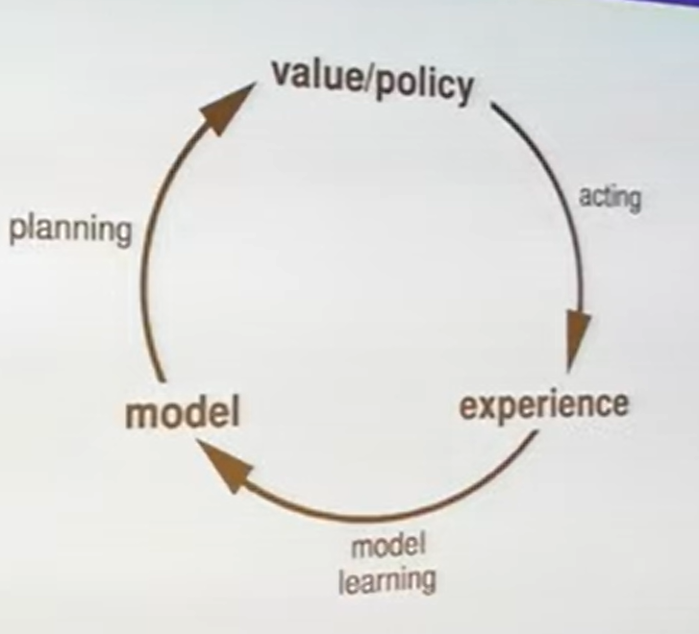

* **Simulate future trajectories**
* **Plan optimal actions**
* **Update its policy or value function**

🔁 How It Works

1. **Model Learning**: Agent collects data (s_t,a_t,r_t,s_{t+1}) and trains a predictive model
2. **Planning**: Uses the model to simulate outcomes of different action sequences
3. **Policy Update**: Chooses actions that maximize predicted rewards

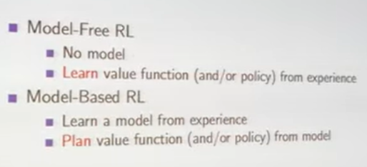

# What is a Model ?

**In reinforcement learning, a *model* is a learned or predefined representation of how the environment behaves. *Model learning* refers to the process of estimating this behavior from data, and there are several types of models depending on what aspect of the environment they capture.**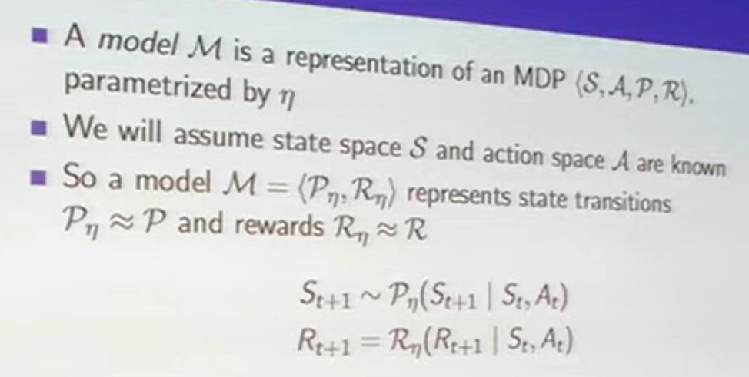

🧠 What Is a Model in RL?

A **model** in RL predicts how the environment responds to actions:

* **Transition model**: predicts next state s_{t+1} given current state s_t and action a_t
* **Reward model**: predicts reward r_t for a given state-action pair
* **Observation model** (in partially observable settings): predicts observations from states

Together, these allow the agent to simulate future outcomes without interacting with the real environment.

🔁 What Is Model Learning?

**Model learning** is the process of estimating the environment’s dynamics from experience:

* The agent collects transitions (s_t,a_t,r_t,s_{t+1})
* It trains a function approximator (e.g., neural network) to predict:
* s_{t+1}=f_{\theta }(s_t,a_t)
* r_t=r_{\theta }(s_t,a_t)

This learned model can be used for:

* **Planning**: simulate future trajectories
* **Policy improvement**: train policies using imagined rollouts
* **Data augmentation**: generate synthetic experience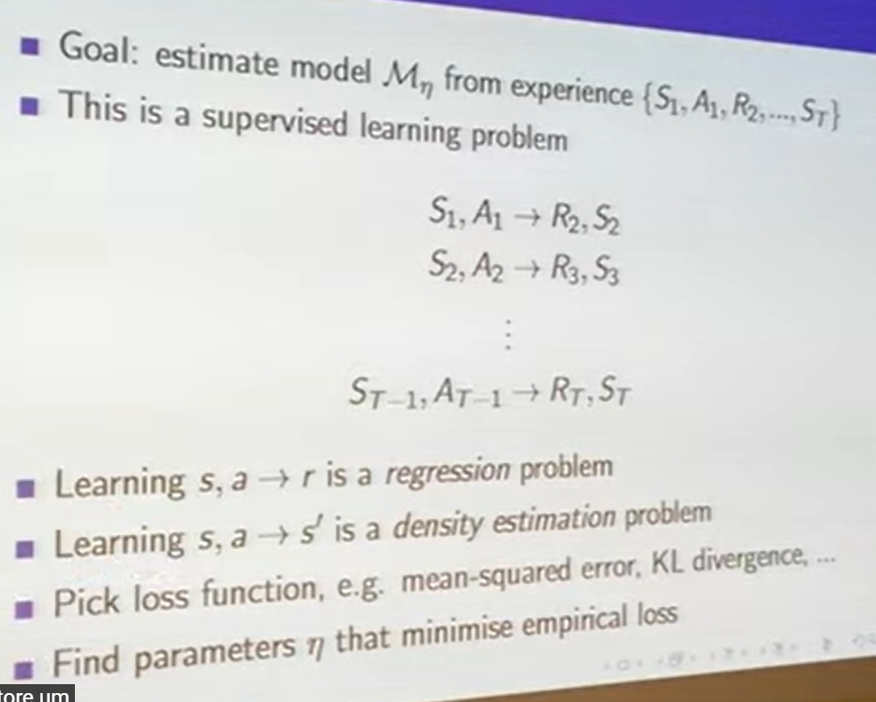

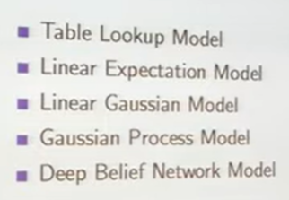

# Table Lookup Model

A **table lookup model** in reinforcement learning is the simplest form of a model where the agent stores exact transitions and rewards in a table, rather than learning a function to approximate them. It’s used when the state and action spaces are small and discrete.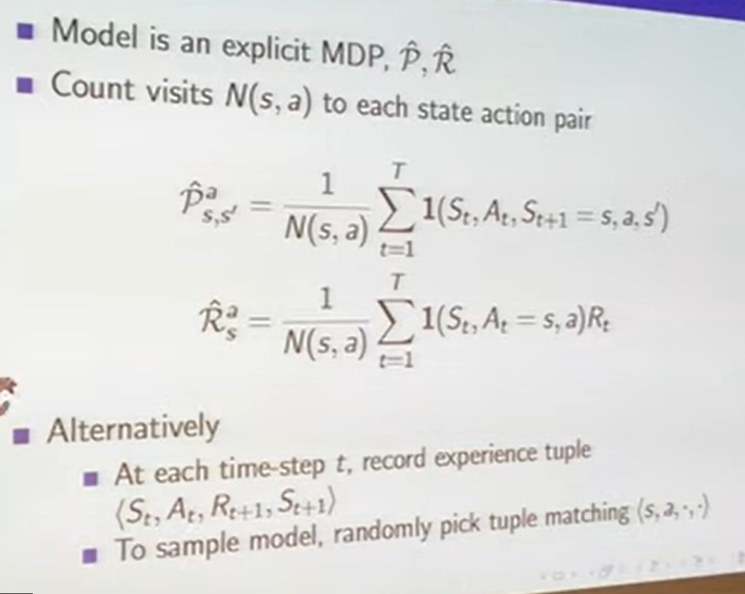

🧠 What Is It?

Instead of learning a function like f(s,a)\rightarrow s',r, the agent builds a **lookup table**:

* For each state-action pair (s,a), it stores:
* The next state s'
* The reward r

This is like memorizing the environment’s behavior.

# Planning in RL

**Planning in reinforcement learning refers to using a model of the environment to simulate future outcomes and make better decisions without needing real interactions. It’s a core idea in model-based RL.**

Planning means : Using a model to **predict future states and rewards**, and then choosing actions that lead to the best outcomes.Instead of learning purely from trial-and-error, the agent imagines what might happen and acts accordingly.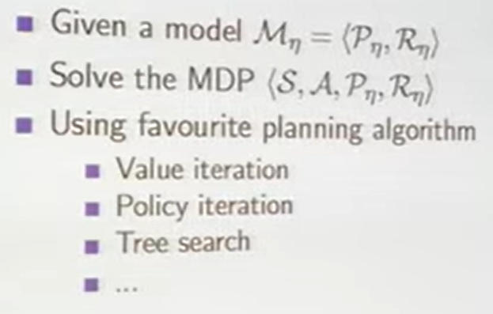

🔁 How Planning Works

1. **Learn a model**: Predict s_{t+1} and r_t from s_t,a_t
2. **Simulate trajectories**: Try different action sequences in the model
3. **Evaluate outcomes**: Estimate total reward for each sequence
4. **Choose best actions**: Use the simulated results to guide real decisions

# **Sample-based planning**

Instead of exhaustively evaluating all possible actions, the agent **samples a few trajectories** from the model and picks the best one.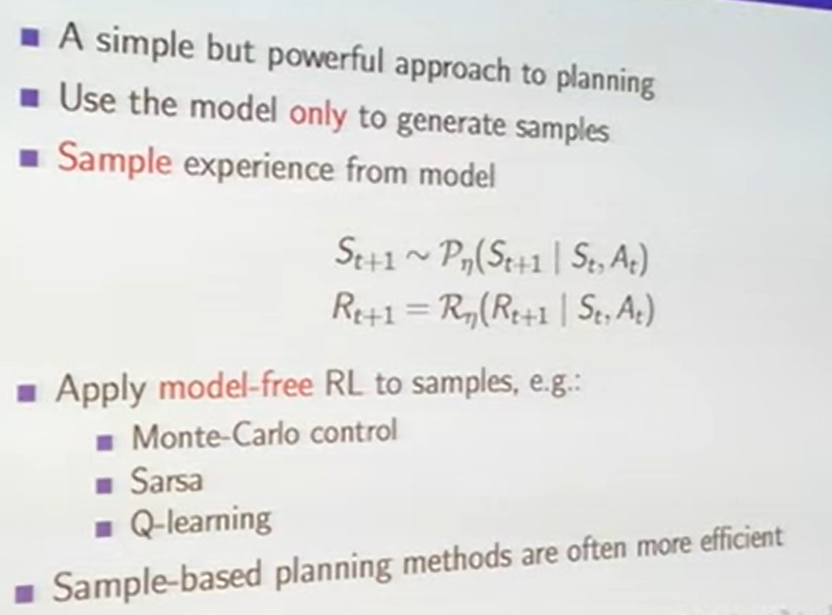

🔹 Example:

* Simulate 10 random action sequences
* Evaluate total reward for each
* Pick the one with the highest predicted return

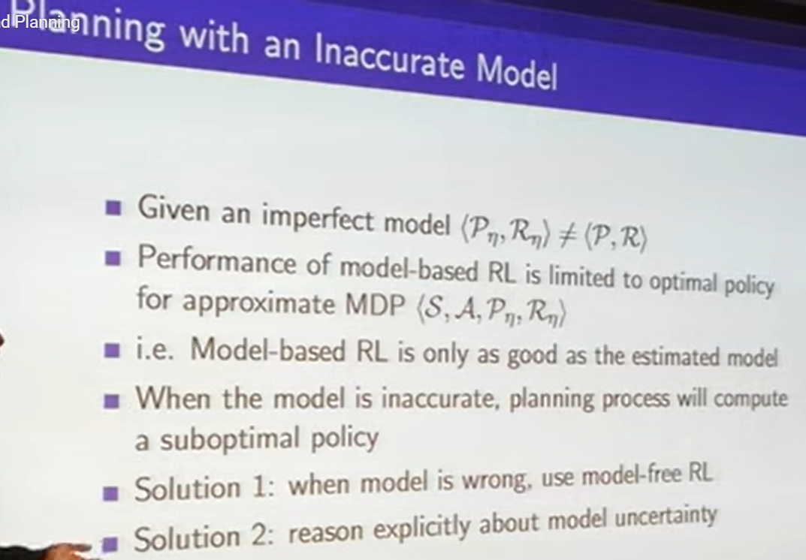

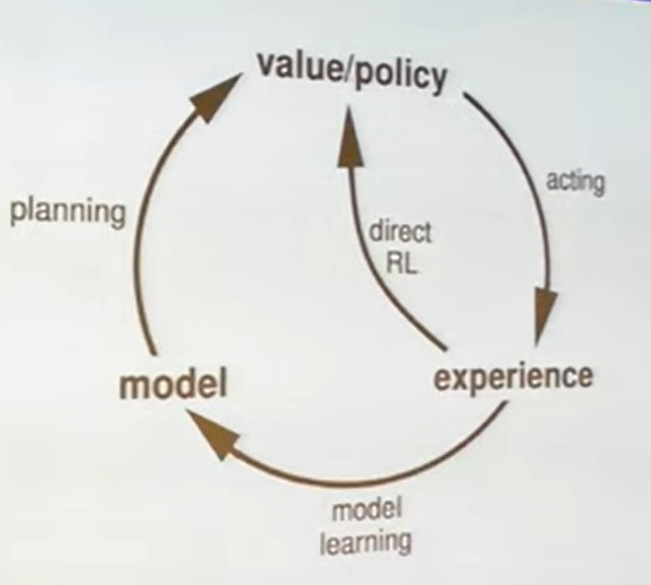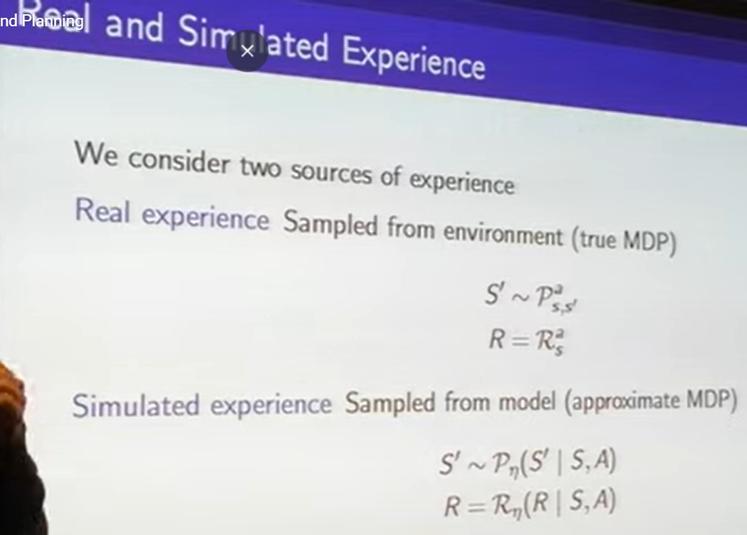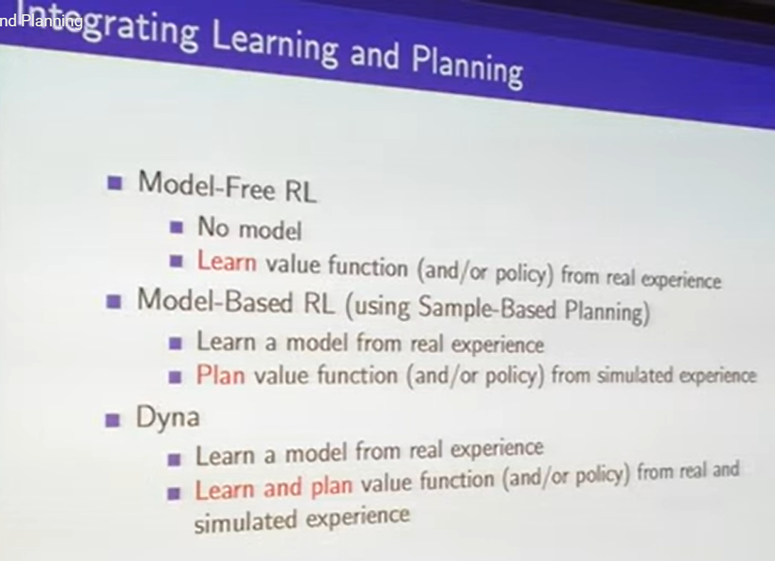

# 🔍 Forward Search

**Forward search** explores possible future states by applying actions starting from the current state, using a model of the environment.

* It builds a **search tree** or graph by expanding:
* Evaluates sequences of actions to find the best one
* Used in **deterministic or known models**

✅ Example:

* A robot plans a path by simulating each move step-by-step
* Algorithms: A*, Dijkstra, breadth-first search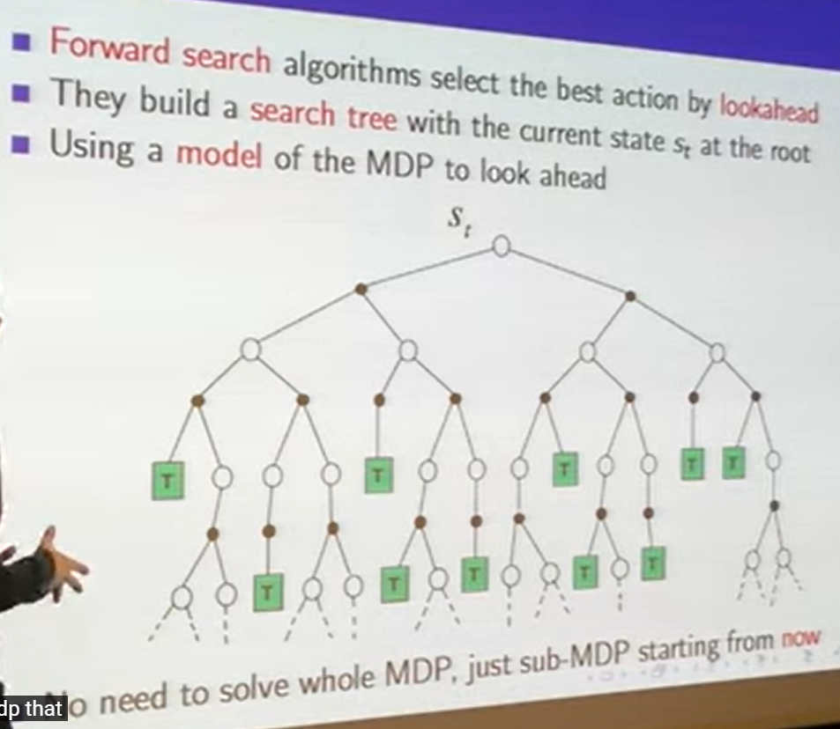

# 🎲 Simulation-Based Search

**Simulation-based search** samples trajectories from a model to estimate action values, often using randomness.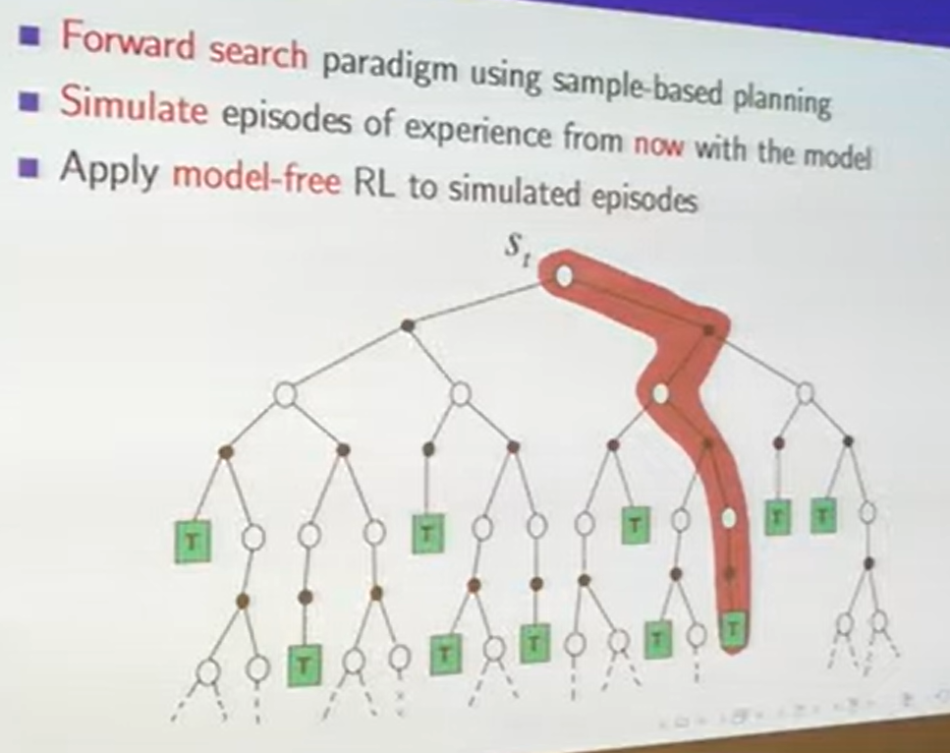

* Doesn’t build full trees — instead **samples rollouts**
* Used in **stochastic or learned models**
* More scalable in large or uncertain environments

✅ Example:

* Monte Carlo Tree Search (MCTS): simulates many random games to pick best move

